

Trust Governance and Compliance Manager
Candidate Pack
Welcome from our Chief Executive Officer

Welcome and thank you for your interest in the role of the University of Chichester Academy Trust (‘the Trust’) Governance and Compliance Manager. This is an incredible opportunity to join our Trust at this key point in its journey.
This key new role within the Central team of the Trust is essential for ensuring that high quality governance and assurance activities are in place across the Trust. You will be joining a team of leaders committed to the highest standards and sharing our common values.
As Governance and Compliance Manager you will be responsible for ensuring high quality governance and assurance activities are in place across the “Trust”, ensuring this important area of operations is working to the highest standards.
This key post will ensure that effective administration and organisation is in place to underpin the Trust’s governance structures and will take a coordinated and strategic approach to working with and aligning each of those key areas of governance.
If you believe you have the ambition, passion, skills and expertise to make a significant contribution to our Trust and its communities, have a strong understanding and experience of leading corporate governance within a dynamic, multi-functional organisation, where you have collaborated successfully with other functions to deliver on the organisation’s strategic governance objectives, we would love to hear from you.
I hope this information pack provides an insight to our Trust. For an informal discussion about the post please contact Phil Matthews, Head of People and Development on (01243) 793499.


“The Trust’s vision to inspire young people, raise aspirations and transform life chances is shared by the school leaders and governors. Strong and effective relationships exist between trustees, the trust’s officers, governors and headteachers.”

Ofsted Review of the Trust
Jennese Alozie
Chief Executive Officer

About the University of Chichester Multi-Academy

The Trust is uniquely placed to make a difference to the local education landscape. Schools who join our Trust do so because they wish to work with like-minded schools who have a shared passion for pupil centered learning, and a desire to work together for the benefit of the wider community that we serve. The Trust is a member of the Confederation of School Trusts and The Queen Street Group.

The Trust has 17 academies in its education family, based in Hampshire, Portsmouth and West Sussex, and a SCITT. Although we share the same vision and values, each of our academies have their own identity which defines them within their local community. The Trust is strongly committed to valuing the uniqueness of each school and governance, through local governing bodies. We offer:

Co-Leadership Approach
The headteachers of our academies all lead their own schools and contribute to the wider leadership of the Trust. Our headteachers have a key role in driving the policies and procedures of the Trust and in leading areas of strategy and projects across our academies.

A Shared Vision:
For all young people to be inspired by an excellent education that raises their aspirations and enriches their lives.

A Shared Mission:
To create a vibrant, inclusive and aspirational family of academies, transforming life chances for pupils through excellent teaching and learning.

Achieve More, Challenge Thinking, Shape Futures

The collective strategic priorities of the Trust are outlined below. The Trust’s Education Development Team have developed a programme, with the University of Chichester, to support all teachers, ensuring evidence-informed practice and professional enquiry promote and meet the strategic priorities.

Learning and Society
Ensure our curriculum offer allows all of our pupils to achieve more and identify with their school community and society as they journey through each of our schools and work closely with our University sponsor.

Strategic Leadership
Develop the leadership capacity and impact of our staff so that they are professionally developed in line with our Trust ambitions and their professional learning pathway.

Collective Responsibility
Invest in and support our staff so that they collaborate to strategically raise the standards all pupils reach and embed evidence-based practices that have an impact on pupils’ learning and identity.

Trust Identity
Ensure our Trust identify and narrative, including our Equality, Diversity and Inclusion commitment, is known to our communities within and outside of the Trust, so that they see, help shape and benefit from being part of the University of Chichester Academy Trust.

Governance within the Trust

Our Sponsor

The University of Chichester is a modern, expanding and ambitious institution with a strong educational heritage.

The University has a long-standing tradition of delivering high-quality Initial Teacher Training and its researchers are recognised as world leading experts in their fields. The University in 2023 was awarded the top Gold rating in the Teaching Excellence Framework (TEF) by the Office for Students, with Ofsted considering the teacher training programmes delivered by the University as ‘outstanding’ in both primary and secondary education.
Approved as an academy sponsor in the summer of 2012, the Academy Trust central offices are based in the heart of the University’s Bognor Regis campus alongside the University’s Teacher Education facility. The staff from the Trust’s academies support the University teacher training programme and the University delivers its National Professional Qualifications Programme with support from expert leaders within the Trust’s academies.
The Trust contributes to the University’s mission to be a learning community which inspires and enables individuals to exceed their own expectations.

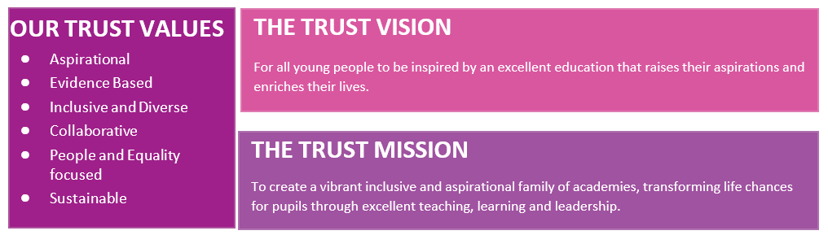
Legal Structure of the Trust

The Trust has been set up as a company limited by guarantee which is the usual legal structure for academy trusts and other not-for-profit companies.
In order to protect the rights and obligations of the Trustees the University of Chichester Academy Trust is registered in England and Wales as a Limited Company Number 8595545. Our Trustees’ therefore, become a Director of the University of Chichester Academy Trust Company.
The governing documents for the Trust are its Memorandum and Articles of Association and these documents set out the role and responsibilities of the two groups of individuals who are responsible for the governance of organisation, our Members and Trustees (the Board).

In order to protect the rights and obligations of the Trustees the University of Chichester Academy Trust is registered in England and Wales as a Limited Company Number 8595545. Our Trustees’ therefore, become a Director of the University of Chichester Academy Trust Company.
The governing documents for the Trust are its Memorandum and Articles of Association and these documents set out the role and responsibilities of the two groups of individuals who are responsible for the governance of organisation, our Members and Trustees (the Board).

Leadership and Governance Structure

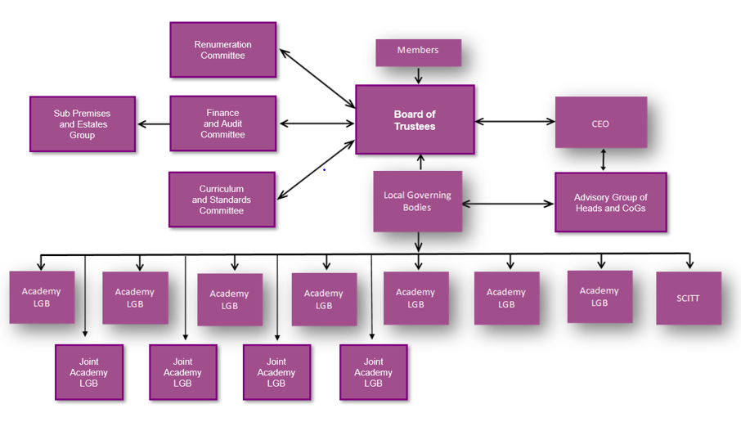

Members

The Members are akin to the shareholders of a company. There are currently four Members, one of whom is also a Trustee.

Trustees (the Board)

The Board has overall responsibility and ultimate decision-making authority for all the Trust’s work, including the establishing and running of academies. The Board has chosen to delegate some responsibilities to governance tiers across the Trust which is set out in a Scheme of Delegation. Focused on a strategic role, Trustees avoid routine involvement in operational matters. The Board hold the Executive Leader, who is responsible for implementing the strategic framework, to account. Further details may be found on our website:
https://www.unicat.org.uk/about-us/the-trust-team/the-trust-board

Local Governing Bodies

All of our academies have a local governing body, or where beneficial, share a local governing body (LGB) which the Trust supports and values. The LGB is a sub-committee of the Board with communications flowing to and from the Board. The LGB provides critical but supportive challenge to ensure the academy is centred within and knowledgeable of, the local community in which it serves.

Celebrating the Unique context of each of our Communities
Although we share the same vision and values, each of our schools have their own identity which defines them within their local community. The Trust is strongly committed to valuing the uniqueness of each school and retaining governance at the local level to ensure the schools reflect the community in which they serve, with trustees and officers sharing this strongly held view.
The Trust has a strong belief that an academy should be strongly grounded in its own community, and the scheme of delegation and the Trust vision and objectives, reflect this key driver. The LGB is a sub-committee of the Board with a two-way flow of communication. GovernorHub is used as the portal for governance communication, with resources provided centrally, and best practice drawn from links with agencies expert in MAT governance. The Chairs of Governors attend termly meetings or workshops, including with the Trust’s leadership team, strengthening the contribution of governance across the Trust.


“The Trust’s vision to inspire young people, raise aspirations and transform life chances is shared by the school leaders and governors. Strong and effective relationships exist between trustees, the trust’s officers, governors and headteachers.”

Ofsted review of the Trust

Our Trust Family

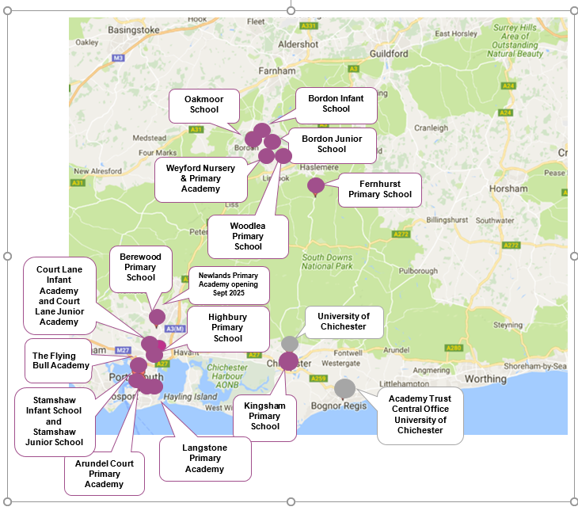



Job Profile

Post: Trust Governance and Compliance Manager

Reports to: Chief Executive Officer

Location: Based at the Central Office, Bognor Regis, with a requirement to travel to and work from the Trust’s Academies across the partnership areas
Grade: Grade 10 £53,460-£58,060

Function of the post:

The post holder will be responsible for ensuring high quality governance, assurance, and compliance activities are in place across the Trust, elevating this critical area of operations to the highest standards alongside other professional business services. They will act as Company Secretary to the Trust, ensuring statutory obligations are met and supporting the Board in its strategic and operational functions.
They will take a coordinated and strategic approach to governance, risk management, and compliance across the Trust, reporting directly to the CEO and working closely with Trustees, Members, and senior leaders. The post holder will also provide line management to the Clerks of Local Governing Bodies and promote a culture of strong governance throughout the organisation.

Principal Accountabilities:

Governance, Company Secretary and Board Management

- Act as Company Secretary to the Trust, ensuring statutory duties are fulfilled and supporting the Board and its Committees in all governance matters.
- Ensure compliance with legal requirements for maintaining accurate records of the Board, Members, and Local Governing Bodies.
- Provide strategic advice and guidance to all tiers of governance on procedural, legislative, and regulatory matters.
- Lead the development and review of the Scheme of Delegation and other key governance documents.
- Draft documentation for the Executive or Board as required, including governance reports, policies, and strategic papers.
- Support the production of key corporate publications, including the Annual Report and Accounts.
- Promote and embed a strong governance culture across the Trust, ensuring clarity, transparency, and accountability.
- Manage relationships with Trustees and Members, ensuring effective communication, reporting, and support.
- Provide line management to Clerks of Local Governing Bodies and facilitate the sharing of best practice.
- Coordinate governance and management processes, including agenda planning, toolkits, training, and decision-making support.

Risk Management and Strategy Development

- Lead Trust-wide risk management, ensuring risks are identified, assessed, monitored, and reported effectively.
- Maintain and develop the Trusts risk register and ensure integration with internal audit and scrutiny processes.
- Contribute to the development of Trust-wide strategy, aligning governance and compliance functions with strategic priorities.
- Provide strategic insight and support to the CEO and Executive Team on governance, risk, and compliance matters.

Compliance

- Scope and recommend the annual internal audit programme in conjunction with the CEO/Director of Finance.
- Lead procurement of external audits in line with legislative and Trust requirements.
- Oversee policy management and ensure compliance with statutory requirements, including website compliance.
- Provide updates on the regulatory environment and required actions to the Executive and Board.
- Ensure Trust compliance with GDPR, leading training, audits, and policy development.
- Manage the complaints procedure and lead investigations in line with Trust policy.
- Lead on subject access and freedom of information requests.
- Conduct Data Protection Information Audits to ensure robust data protection across the Trust.
- To undertake the role of Data Protection Officer for the Trust

Other duties:

You are required to undertake such other duties appropriate to the grade and content of the work as may reasonably be required of you including to understand and actively embrace the Trust’s distinctive sensibility, the qualities, values and characteristics expected of everyone working for our Trust.

University of Chichester Academy Trust:

The Trust’s vision is “For all young people to be inspired by an excellent education that raises their aspirations and enriches their lives”, and it is our mission “To create a vibrant, inclusive and aspirational family of academies, transforming life chances for pupils through excellent teaching and learning…”

With a supportive and collaborative approach, it is expected our academies are actively engaged and contribute to the work of the Trust; have a shared vision and work within the requirements of the Trust whilst retaining and developing the academy’s own identity.

Equality and Inclusion:

The Trust believes that everyone has the right to be treated equally and that the diversity of individuals and groups should be embraced, valued, and respected. We are committed to eliminating any form of discrimination be it direct, indirect, harassment or victimisation, and to support this the Trust has a number of policies that you should ensure you are familiar with and compliant to. Any breaches may lead to termination of employment.

Right to Work:

British Law states that a person cannot be employed to this post if they do not have permission to live and work in the UK. Please advise if you require any guidance or further information.

Health and Safety:

You are responsible for ensuring that workplace responsibilities within the Section are carried out with full regard to, and in support of, the Trust’s Health and Safety Policies.

Sustainability and Environment:

The Trust is committed to sustainable development and environmental initiatives. It accepts its environmental responsibilities and recognises the contributions it can make to the resolution of regional and local environmental issues. The Trust will support the academies in continuously seeking to find ways to improve their environmental performance and all staff are required to support these aims.

Data Protection:

You will be responsible for conducting activities in compliance with the requirements of current Data Protection Legislation and the Employment Practices Data Protection Code, especially concerning confidentiality, treatment of personal information and records management.

Safer Recruitment:

The Trust are committed to safeguarding and promoting the welfare of children and young people and expect all staff to share this commitment. We will ensure all our recruitment and selection practices reflect this commitment.

Principal Attributes and Person Specification:

Essential requirements are those, without which, the candidate would not be able to do the job. It is expected that the post holder will have the knowledge and qualifications indicated, or equivalent qualifications and/or experience.

Desirable requirements are those which would be useful for the post holder to possess and will be considered when more than one applicant meets the essential requirements.

 | Essential | Desirable | Evidence
Knowledge and Qualifications |  |  | Application  Interview
Degree level or equivalent experience |  |  | Application  Interview
Post qualification experience relevant to the post. |  |  | Application  Interview
Knowledge and familiarity with governance structures within public sector organisations |  |  | Application  Interview
Relevant degree and/or professional qualification, e.g. The Chartered Governance Institute (formerly ICSA), law, accountancy, GDPR, audit or equivalent knowledge and experience. |  |  | Application  Interview
Knowledge and understanding of education legislation, guidance and legal requirements |  |  | Application  Interview
Knowledge of DfE and ESFA requirements and Multi Academy Trust best practice. |  |  | Application  Interview
Skills |  |  | Application  Interview  References
Strong written and oral communication skills and the confidence to challenge others, at whatever level, when sound corporate governance would be undermined. |  |  | Application  Interview  References
Excellent people skills to support engagement with staff at all levels across the Trust and beyond. |  |  | Application  Interview  References
Proven ability in planning and organisation, with good attention to detail. |  |  | Application  Interview  References
The ability to act with detachment and impartiality in order to serve the best interests of the Board and the Senior Leadership Team. |  |  | Application  Interview  References
Confidence in interpreting and applying legislation. |  |  | Application  Interview  References
Integrity and a respect for confidentiality |  |  | Application  Interview  References
Ability to prioritise and to keep to deadlines within a challenging environment. |  |  | Application  Interview  References
Ability to rapidly develop confidence and trust with people at all levels throughout the organisation. |  |  | Application  Interview  References
An ability to grasp complex issues and demonstrate sound judgement |  |  | Application  Interview  References
Excellent IT skills |  |  | Application  Interview  References
Experience |  |  | Application  Interview  References
A strong understanding and experience of leading corporate governance with a dynamic, multifunctional organisation, collaborating successfully with other functions to deliver on the organisation's strategic objectives. |  |  | Application  Interview  References
Experience of advising senior management and Boards, preferably within a highly regulated environment. |  |  | Application  Interview  References
Experience of successfully planning and implementing a Strategy which includes improving processes and policies across an organisation. |  |  | Application  Interview  References
Experience in managing/leading a team and or function, setting and monitoring performance objectives. |  |  | Application  Interview  References
Ability to contribute strategically with experience of leading and influencing change. |  |  | Application  Interview  References
Experience in a similar role in an education setting. |  |  | Application  Interview  References
Personal Attributes |  |  | Interview  References
Committed to the values and vision of the organisation. |  |  | Interview  References
Understand, promote and uphold policies for safeguarding children and young people. |  |  | Interview  References
An ability to maintain absolute confidentiality and integrity; being trustworthy and honest. |  |  | Interview  References
Personal achievement of goals through influence. |  |  | Interview  References
Committed to Equality, Diversity and Inclusion. |  |  | Interview  References
Committed to the Nolan principles. |  |  | Interview  References
Committed to excellence in governance |  |  | Interview  References

Privacy Statement

The Trust collects information about you in order to provide you with recruitment and employment services. We will use this information for the recruitment and selection process and, if successful, to activate employment with the Trust.

The legal basis for processing your personal data is that it is necessary for the performance of the employment contract or in order to take steps before entering into a contract and is necessary for the Trust to comply with a legal obligation.

The legal basis for processing special category data is that processing is necessary for the purposes of carrying out the rights and obligations in the field of employment, that it is necessary for the reasons of substantial public interest and that it is necessary for the purposes of the assessment of the working capacity of the employee.

We will keep your personal information for six months following the interview date if you are not successful, and for the duration of your employment plus six years if you are successfully appointed.

You have some legal rights in respect of the personal information we collect from you. Please see the Trust’s website for further details on their privacy notice and data protection policy.

You can contact the Trust’s Data Protection Officer at unicat.org.uk if you have a concern about the way the Trust collects or uses your data.

Application Procedure

To apply for this vacancy, please download the application form from the University of Chichester Academy Trust (https://www.chimat.uk/vacancies) and send it to Jake Whittle, Recruitment Coordinator, at UNICATRecruitment@chi.ac.uk.
The application deadline is 10th November 2025
The Interview date will be in W/C 17th November 2025
Start date: February 2026 or sooner if possible.

University of Chichester Academy Trust
People Team
Arran House
Bognor Regis Campus
Upper Bognor Road
Bognor Regis, PO21 1HR

T: 01243 793499 E: unicathr@chi.ac.uk

Application Form Completion

When completing the application form, please refer to the Job Profile and particularly the Person Specification in the context of the accountabilities. Please detail in the application form how you believe your experiences and this role will contribute to our Trust Vision and Mission.

You should provide examples which evidence how you believe your knowledge and qualifications, skills, experience and personal attributes, either at work, or elsewhere, qualify you to undertake the duties and responsibilities set out in the Job Profile.

CV

You may submit a separate sheet detailing your qualifications and previous employment. All other information requested should be contained within the application form.

If there are any dates unaccounted for you should detail the reasons in the relevant field on the application form.

Selection Procedure

The shortlist will be completed shortly after the closing date and successful candidates will be invited to a selection process.

Failure to send your application form to the above address may invalidate your application.

Receipt of Application

Applications are acknowledged (by email whenever possible) within three working days of receipt. If you do not receive an acknowledgement within this time, please contact the Central People team on the number above.

Support

If you have any specific support or adjustments that you would like the Trust to consider or arrange for you, please contact Jake Whittle, Recruitment Coordinator, at UNICATRecruitment@chi.ac.uk.

