 |  |  | 
 |  |  | 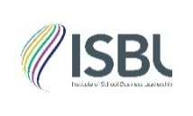
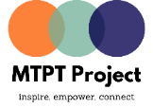 | 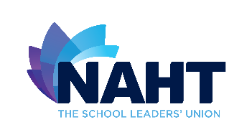 |  | 
Statement of action and commitments on equality, diversity, and inclusion in education
November 2024
Purpose
This is a public statement by organisations working in the education sector to demonstrate their commitment to playing their part in acknowledging the issues and furthering equality, diversity and inclusion in schools and trusts by taking action. We are working in a number of ways: independently, together and through our networks and others’.
Signatories will hold each other to account for delivering on these aims and will be held to account by our respective members and stakeholders. By being transparent about our actions, we want to give confidence to pupils and families, staff and leaders and those governing that we are learning, listening and acting on their concerns and ambitions for equality, diversity and inclusion. The progress and impact of these commitments will be reviewed every 12 months and an updated statement published.
Signatories
The organisations that are signatories to this statement are:
- All-in Education
- Ambition Institute
- Association of School and College Leaders (ASCL)
- Chartered College of Teaching
- Diverse Educators
- Diversity Role Models
- Independent Schools Council (ISC)
- Institute of School Business Leadership (ISBL)
- Maternity Teacher Paternity Teacher Project
- NAHT, the School Leaders’ Union
- National Governance Association (NGA)
- WomenEd
The 2024/25 commitments
All-in Education
Johan Jensen, Director of All-in Education said: “We believe that advancing equity in education requires ongoing self-reflection, decisive action, and consistent evaluation of outcomes. At All-in Education, we are committed to evolving how we collaborate with the sector and ensuring that our services generate meaningful impact for governors, staff, pupils, parents, and the broader school community”. To achieve meaningful impact on equality, diversity and inclusion in education All-in Education works in partnership with other respected organisations including RSAcademics and Trust Inclusion – working together enables us to provide an even higher standard of EDI solutions to the sector.
Developments since the 2023/24 statement
Over the course of 2023-24 All-in Education has focussed on three areas to support schools:
- In June 2024 All-in Education launched the pioneering independent schools sector Minority Ethnic Governors Network (MEGN). This comes after consulting governors across the independent sector; governors told us that there is a critical need for a network that unites governors from global majority backgrounds. The purpose of the network is to provide peer support to identify best practice and positively impact the independent schools sector as a whole.
- In partnership with Trust Inclusion we have launched a new Inclusive People Leaders Programme, supported by a range of education leaders such as Leora Cruddas, CEO of CST and Sir David Carter, former National Schools Commissioner. The programme is offered to Schools Trusts and is a totally different people leadership programme for school leaders. It includes all the fundamentals of understanding how best to lead people and manage things well. Uniquely, creating and maintaining an inclusive culture will be at its heart and evident in every aspect of content and facilitation.
- We have continued to develop inclusive senior leadership teams in schools and groups of schools, and built substantial diversity and inclusion expertise to enable long-term strategies for change. We have also continued to conduct in-depth inclusive recruitment audits and training to increase representation of talent from underrepresented groups.

Commitments for 2024/2025
- The schools we work with continuously report to us about the quantitative and qualitative impact our support has generated for them in recruitment, talent management, pupil experience and achievement. We will publish an impact report which will showcase best practice from across the maintained and independent school sectors.
- Since we were founded in 2018, we have supported schools internationally to become work and learning places where people feel a strong sense of belonging and inclusion. We will work with more education institutions internationally and to collaborate with our partners RSAcademics and iGNIS to ensure our impact benefits the international school sector as a whole.
- Grow the network of global majority governors in the independent sector through MEGN and work with organisations such as AGBIS to raise awareness of the importance of representation and anti-racism in school governance.
- We will continue to increase the number of schools and School Trusts we work with and continue our exciting collaboration through Trust Inclusion to achieve this. Our partnership with Trust Inclusion will also see a number of cohorts of School Trusts leaders start their Inclusive People Leaders Programme (IPLP) as well as developing a tailored IPLP for the independent school sector.
- In addition, All-in Education will offer a range of services to schools in the UK and internationally, including:
  - its flagship leadership development programme, which combines training and facilitated discussions to support senior leaders in developing EDI strategies.
  - comprehensive training packages for classroom practitioners to help them create inclusive learning environments.
  - audits to support the development of whole-school EDI strategies for curriculum development, governance, and inclusive staff recruitment.

Ambition Institute
Hilary Spencer, chief executive at Ambition Institute, said: “Every child deserves a great education, regardless of their background or circumstances. We believe taking action to strengthen equality, diversity, and inclusion in education is crucial to achieving our mission and providing every child the best start in life.
“We are committed to developing a more equitable system for the education workforce, the pupils they teach, and within our own organisation, where everyone is included and feels a sense of belonging.
“We were pleased that our recent Ofsted inspection highlighted that “inclusive practices sit as core principles” across our programmes. We recognise that there is always more to do. We have updated our EDI Strategy for 2024-25 and look forward to making more progress over the coming year.”

Developments since the 2023/24 statement
In 2023/24, Ambition:
- Designed and launched our NPQ for SENCOs programme, which will support school leaders to build inclusive cultures and develop high quality provision for pupils with special educational needs and disabilities.
- Put diversity and inclusion at the core of recruitment and application processes for our new Initial Teacher Training programme, and within its programme design, to attract a diverse range of participants.
- Put our SEND specialists at the heart of designing our new Initial Teacher Training programme. This will ensure that our trainees learn to teach in a way that is inclusive of pupils with a wide range of learning needs, right from the start of their career, and that all children in their classrooms feel supported to succeed.
- Developed our ECF and NPQ programme materials with diversity, inclusion, and accessibility at the heart of our approach. 95% of NPQ participants now feel that we represent a diverse range of characteristics in our programme materials.
- Reviewed the eligibility criteria for all our programmes to ensure people from all backgrounds are encouraged to apply.
- Collaborated with Trusts and groups of schools to explore flexible working initiatives, to make sure that teaching is an increasingly inclusive profession.
- Trialled race equity training from Power the Fight and Class 13.
- Published our first report on the gender pay gap at Ambition, which we were pleased to report is 0.13% (median) and 0.62% (mean), compared to national averages of 14.9% and 14.3% respectively.
- Implemented a new anonymised recruitment platform, aiming to reduce unconscious bias from our hiring processes.
- Supported our staff affinity networks to deliver a range of initiatives, including creating spaces for colleagues with shared lived experiences, and raising awareness of different celebrations, experiences, and issues. Some recent initiatives include a series of blogs, Being Mixed Race, from our Race Equality Network, and events on maternal and child mental health from our Parents’ Network and the Mental Health and Wellbeing Network.

Commitments for 2024/2025

Over the course of 2024/2025 Ambition plans to:
- Standardise our approach to EDI across all our programmes, both in terms of programme materials and how the programmes are delivered by trainers.
- Update our contracts and quality assurance processes to clearly lay out the standards we expect from all our delivery partner organisations with regard to EDI.
- Review and introduce more ways to increase the representation of underrepresented groups at all phases of our teacher training and professional development programmes.
- Analyse retention, satisfaction, and outcomes by different participant groups (gender, ethnicity and disability status) across our ITT, ECF and NPQ programmes.
- Work with other lead providers, organisations, and schools to share insights and best practice on improving equality, inclusion and belonging.
- Seek partnerships with organisations that are specifically focussed on improving racial equality and inclusion for pupils with SEND.
- Continue to run our annual pay equity review.
- Review diversity in leadership positions at Ambition and explore options to increase the representation of underrepresented groups across the organisation.

Association of School and College Leaders (ASCL)
Julie McCulloch, Senior Director of Strategy, Policy and Professional Development Services said: “ASCL’s mission is to speak on behalf of members and act on behalf of children and young people. Over the last few years, our focus has been on how we ensure that means all pupils and leaders, especially those with particular protected characteristics or other vulnerabilities. Our annually updated EDI plan has three strands, which focus on ourselves as an organisation and an employer, on our governance, and on our influence across the system. We are proud to add our commitments to those of other organisations and look forward to continuing to work together in the coming year.”
Developments since the 2023/24 statement
Since the last publication of this statement of action ASCL has:
- Held a training session for all staff on EDI, led by an expert facilitator
- Sought external advice on reviewing our recruitment polices and processes to remove any barriers to talented people from diverse backgrounds applying for roles at ASCL, and to ensure we actively encourage and enable people from groups currently under-represented on our staff or in particular teams to do so
- Successfully encouraged a more diverse group of members to stand for election to ASCL Council, our policymaking body
- Undertaken market research to better understand the needs, desires and challenges of leaders in different roles and sectors, and from different backgrounds
- Supported our EDI networks to further establish themselves and to expand their membership, including by encouraging network members to produce blogs, articles and videos
- Strengthened the links between the EDI networks and our policy work, including through discussing policy positions, papers and consultation responses with network members to ensure we have considered them from the perspective of members with diverse backgrounds
- Staged a second EDI conference, and established this as an annual event on our professional development calendar
Commitments for 2024/2025
Over the course of 2024– 2025 ASCL commits to:
- Publish our gender pay gap
- Embed the advice we have received on inclusive recruitment, including through bespoke training for all managers
- Evolve our EDI networks into new Professional Leadership Communities, and expand our focus to explore the needs of neurodiverse leaders
- Strongly encourage the new government to re-focus attention on the lack of diversity in school and college leadership, and to commit to actions it can take to improve this as part of its recruitment and retention strategy
- Continue to build and strengthen our relationships and partnerships with other organisations which share our values and ambitions

Chartered College of Teaching
Dame Alison Peacock, Chief Executive of the Chartered College of Teaching said: “In our increasingly divided communities, it is more important than ever that we support diversity, equity and inclusion in our schools and colleges. Education is key to addressing the prejudices and biases in our society, and to offering hope for a more inclusive future.
“Our students need a curriculum that reflects their lived experiences, inclusive pedagogies and opportunities for every person to achieve. Our profession needs open and honest conversations about the importance of diversity, to put equity and inclusion at the heart of practice. As the professional body, we are committed to supporting teachers at all stages of their careers to build their understanding so that they can better support and challenge their students.
“Our mission is to empower the profession to make a difference to the lives of children and young people, both in the classroom and in the wider education system. We are committed to increasing the diversity of the profession, to addressing the barriers to entry and progression that too many teachers face, and to ensuring that we hear and amplify the voices of those whose expertise is too often undervalued.”
Developments since the 2023/24 statement
- Continued to engage and represent with the Chartered College with partners such as WomenED, the Institute of Educational and Social Equity and DiverseED, as well as sponsoring the inaugural London edition of the Racial Equity Network Dinner
- Continued to provide a range of webinars, discussions, research and events to support teachers in areas of diversity and inclusion, including:
  - A series of six learning modules on Leading Inclusive Schools
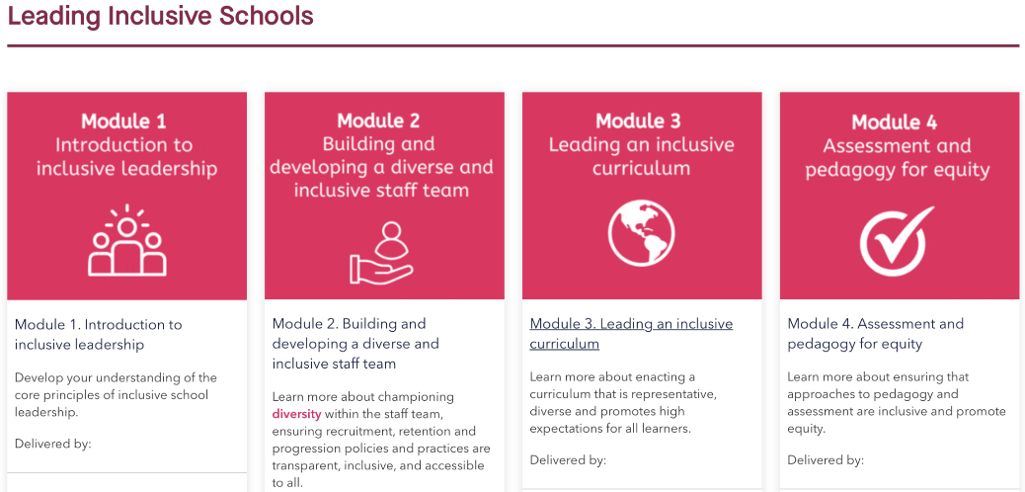
  - An ongoing series of six learning modules on Decolonising and Diversifying the Curriculum
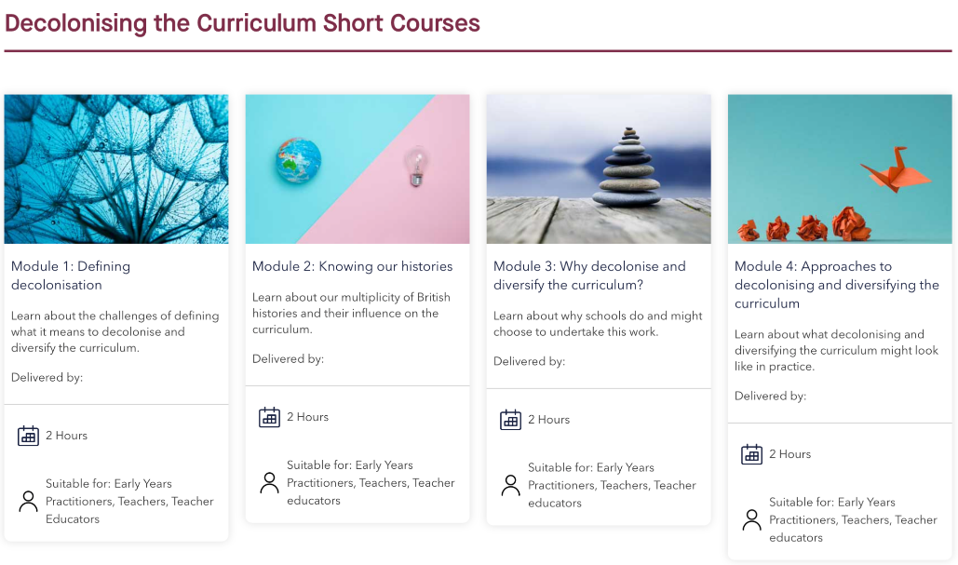
  - Articles on areas such as ‘Reframing “disadvantaged” as “underserved”’, ‘Assessment for learners with SEND’, ‘Practising inclusion in secondary schools’, ‘Levelling the playing field of learning’ and ‘Creating an anti-racism inclusion group at school’.
  - Ongoing celebration and advocacy of key commemorative periods, including International Women’s Day, LGBTQ+ History month, with a focus on supporting inclusion, and Black History month, focussing on supporting greater diversity and equity in leadership positions
  - Webinars on areas such as ‘Women inspiring inclusion’, ‘Place-based and community curricula’, ‘Holistic approaches to assessment’, ‘Closing the attainment gap for boys’ and ‘Developing a whole-school approach to gender equity’.
  - A book chapter in the BERA Guide to Decolonising the Curriculum, co-authored by our Head of Research and Policy, Dr Lisa-Maria Muller, our former colleague and Curriculum Designer at the Teacher Development Trust, Hannah Tyreman, and the BERA president and Chartered College of Teaching Fellow, Dr Marlon Moncrieffe.
- Sought to build understanding of diversity, equality and inclusion through projects, professional learning and accreditation activity, including:
  - A journal club project focusing on SEND
  - DEI as a central component and common thread to our Rethinking Curriculum primary project
  - Ongoing review and development of assessments and assessment processes to minimise bias, with assessment bias training under development for assessors
- Presented findings from our journal club project focusing on SEND and teacher-TA dialogue at the BERA conference in September 2024.
- Compiled a line manager training course and resources with specific sections on creating an inclusive and diverse workforce and recruitment bias training
- Provided monthly resources to all staff via our Team Hub to raise awareness of, and develop understanding within, a variety of EDI topics
- revisited our recruitment strategy and discussed changes to make to ensure barriers are removed during the recruitment process and ways to increase the racial diversity of our workforce.
- Re-issued our staff EDI self-efficacy survey to compare responses and identify further development needs and training for staff
Commitments for 2024/2025
- Continue to work with the profession – through our established Ethics Committee and Diversity and Inclusion Group, and across our membership offer, to ensure that we no longer see a disparity between the diversity of pupils and the diversity of teachers and leaders.
- Continue to work closely with the Department for Education (DfE) and other supporting organisations across the profession on the delivery of the Equalities and Diversities agenda, encouraging and promoting good practice to our membership.
- Continue to lead events, webinars, discussions, research and the provision of content, tools and support materials for teachers in areas of diversity and inclusion, across our platforms and in our journal, Impact.
- Continue to target CPD for our own staff team in areas that have been identified as needing further improvement in our staff self-efficacy survey, in order to further develop our understanding.
- Roll out the staff self-efficacy survey on an annual basis to target staff CPD, measure its impact and identify new areas for improvement
- Continue to work closely with partner organisations and inclusive job opening sites to recruit more diverse candidates for future vacancies and continue to monitor and improve the recruitment process to ensure inclusivity across all areas of diversity.
- Continue to encourage and promote diversity in our employee recruitment process, as well as within our governance structure, led through our Diversity and Inclusion Group
- Monitor and publish our membership diversity, to ensure that our membership reflects and is inclusive to the diversity of the profession.
- Assess the accessibility of all Chartered College tools, products and services to understand and overcome barriers and ensure we are as inclusive as possible for all members and the profession.

Diverse Educators
Hannah Wilson, Co-Founder and Director of Diverse Educators, said: “Our children in our schools are diverse and our schools serve diverse communities, thus we need to ensure that we have diverse representation at every level of the school system. Diversity, equity and inclusion (DEI) need to be a strategic priority for every school, for every leadership team and for every governing board to ensure that we create a sense of belonging for all. We need a coherent and cohesive system-wide approach to addressing the inequities and barriers that oppress and marginalise groups of educators so that we can recruit, develop, retain and promote diverse educators. DEI needs to be a golden thread that runs through every policy, every practice, every person in every school.”
Developments since the 2023/24 statement
- DEI Directory of 210 organisations to signpost organisations working in DEI
- Coaching Directory launched spotlighting 40 diverse coaches
- Blogs from diverse educators being published 2–3 times a week
- Monthly newsletter signposting DEI activity
- 39 DEI Toolkits collated and published
- Reading lists collated and published
- Glossaries collated and published
- DEI podcast for ITTE - 2nd series published in partnership with NASBTT
- DEI leaders programme launching its 20th cohort
- Diversity in the curriculum programme launching its 5th cohort
- DEI training for SCITTs
- Termly Diversity in ITTE network meeting
- Termly DEI leaders in schools network meeting
- Termly DEI for HR network meeting
- Annual virtual ITTE and ECT event
- Annual virtual governance event
- Annual virtual pastoral event
- Annual virtual DEI leaders event
- Annual virtual diversity in the curriculum event
- World Book Day event to amplify diverse authors
- Presenting at national events such as ASCL, NAHT, NEU
- Presenting at trust-conferences
- Collaboration with Myatt & Co
Commitments for 2024/2025
- More DEI Toolkits being developed on key themes
- Curriculum resources being collated as best practice
- Collaborative partnerships being developed
- Launching a new event in Scotland with SCIS
- Jobs board being launched
- Coaching partnership being piloted
- CQ certification cohort being piloted

Diversity Role Models
Alex Feis-Bryce, CEO of Diversity Role Models: “As an education charity whose mission is to promote understanding and acceptance of individual differences and end LGBTQ+ bullying in schools we remain determined to create inclusive learning environments where young people know they are valued and supported, regardless of their differences.
This year, we will continue to share best practice in tackling prejudice and discrimination and support educators in embedding inclusive practices in their settings. We are excited to continue to work collaboratively across the sector to promote diversity, equality and inclusion and work together to end prejudice-based bullying.
As a charity, we want to live our values and will continue to improve our internal policies, processes and practices to better support our diverse community of staff and volunteers as well as the young people, teachers, parents/carers and governors that we support.”
Developments since the 2023/24 statement
Diversity Role Models were not previously signatories of the Statement of action and commitments on equality, diversity, and inclusion in education.
Commitments for 2024/25
Over the course of 2024/25 we will focus on the following key areas:
- Sector wide: Promoting best practice in relation to tackling and preventing prejudice-based bullying through disseminating the findings of our Embracing Difference, Ending Bullying Evaluation and Impact Report and Best Practice Guide.
- Sector wide: Collaborating with others across the sector to seek to ensure that Relationships, Sex and Health Education and other key pieces of statutory/non-statutory guidance help promote equality for all within schools, including for transgender and non-binary young people.
- Service delivery: Delivering educational sessions on LGBTQ+ equality and celebrating all differences to more young people than ever before.
- Service delivery: Continuing to support staff, parents/carers and governors with training and resources that help them tackle and prevent prejudice and provide positive representation of a diverse and intersectional range of Role Models.
- Service delivery: Continuing to develop our work focusing on tackling and preventing all forms of prejudice-based bullying to complement our work on LGBTQ+ equality and inclusion.
- Service delivery: Working with disability and neurodiversity inclusion experts to improve the accessibility of our presentation materials for our service delivery to ensure we better serve disabled and/or deaf, and/or neurodivergent service users.
- Improving policies and practices: Reviewing and improving our recruitment practices to ensure they effectively mitigate bias.
- Improving policies and practices: Ensuring staff and volunteers have relevant CPD on a wide range of equalities issues.
- Improving policies and practices: Updating and improving key policies in relation to diversity, equality and inclusion and introducing a ‘ways of working’ agreement for our staff team and our trustees that has a commitment to diversity, equality and inclusion at its heart.
- Improving volunteer policies and practices: Continuing to expand and diversify our volunteer Role Model network to ensure representation across the full spectrum of LGBTQ+ identities and intersectional experiences, with a focus on increasing representation of transgender and non-binary people and LGBTQ+ people of colour.
- Improving educator voice: ensuring our Education Steering Group is representative of the diversity of young people and educators we serve through formalising our Education Steering Group membership and recruiting a diverse panel of experts.
- Improving youth voice: Ensuring our Student Voice Group is representative of the diversity of young people we serve by actively recruiting students from a range of backgrounds to attend our Student Voice Group. Ensuring we are considering and including youth voice and perspectives in the design and implementation of Diversity Role Models programmes.

Independent Schools Council
ISC Chief Executive Julie Robinson said, “The Independent Schools Council and the associations it represents fully support efforts to tackle racism or any other type of discrimination – we need positive, meaningful change”.
The ISC’s Inclusion and Diversity Group helps co-ordinate work across the independent schools sector. It is populated by association staff and serving practitioners in schools. It brings together experience, people from different backgrounds and a range of committed voices around the table.
While it is for each individual school to address equality and diversity issues within their own setting, the role of the ISC Inclusion Group is to bring together guidance and best practice to support schools plan what steps they need to take.
The group has agreed a range of actions to help deliver its agreed vision which is: ‘To create an inclusive culture in our schools where all staff and pupils feel comfortable, respected and valued”.
While the initial driver for the group was BAME racism – the group’s work seeks to address the needs of all ethnic and religious groups and tackling all forms of discrimination based on protected characteristics in the Equality Act.
To help provide a framework for schools, the Inclusion Group set up a number of workstreams to produce guidance or best practice to support schools. The workstreams have completed their initial tasks with materials available to schools on the member’s area of the ISC website. They had covered: schools policies/compliance; legal issues; staff training; recruitment; teaching and curriculum; use of language; and a schools role within local communities. Outputs included:
- Towards an Equality, Diversity and Inclusion Strategy (AGBIS and Farrer & Co) – a guide for governors and senior leaders on developing a whole school strategy on EDI
- A best practice guide on broadening recruitment
- Legal guidance notes on EDI policies and procedures

Alongside this, the ISC website signposts information for schools. Within our diversity pages schools can find:
- A list of useful resources – including links to external organisations and information from the Equality and Human Rights Commission
- School case studies on equality and diversity
- Links to training provided by ISC member associations
Individual associations within ISC will also have their own EDI committees and will be supporting schools through guidance, training and webinars. Over the past year there has been a focus on gathering data from schools on senior leaders and staff to help benchmark progress.

Institute of School Business Leadership (ISBL)
Stephen Morales, Chief Executive Officer of ISBL, said: “By embracing diversity, equity, inclusion, representation, and an overall sense of belonging, we can significantly and positively change perceptions of the world around us and all those who inhabit our communities.”

Developments since the 2023/24 statement
Since the last publication of this statement of intent, we have:
- continued to deliver EDI training to school business professionals
- supported multi-academy trusts in embedding EDI strategies
- conducted an impact evaluation study of our EDI work
- sponsored the mentoring of an aspiring school business leader from a minority ethnic group
- recruited more Black and Asian colleagues to our executive and non-executive teams
- presented EDI champion Sufian Sadiq with a national award in recognition of his work
- put ISBL’s CEO through the EDI Fellowship programme with the Institute for Educational & Social Equity.

Commitments for 2024/25
We remain committed to the principles set out in our EDI pledge. We aim to continue our work to better educate our school business professional workforce. We now enjoy better representation across our executive team, trust board, and advisory panel. We continue to ensure speakers at our national conference and regional events properly represent the communities we serve. This year at our national conference, we aim to celebrate the early success and promising future of a young Black school business professional who we are sponsoring through coaching and mentoring.

ISBL’s CEO recently completed an EDI leadership programme and will use learnings to inform positive action and change.

ISBL’s EDI pledge
We believe in three anchor points that ensure the ISBL proposition is as inclusive as possible:
- Access: Being able to fully engage and participate in all ISBL activity with equal ease and dignity
- Treatment: To feel a sense of belonging – a place where we fit in, are welcome, and can express ourselves in our own way
- Service: Feeling that training programmes, events, and resources have been designed with us all in mind

We value diversity – it makes ISBL a more creative place to learn and interact.

We celebrate the fact that our members, staff, partners, and supporters are from different social and ethnic backgrounds, have different sexual orientations, participate in a variety of faiths, and have a range of disabilities.

All the evidence suggests that:
- diverse teams make better decisions and produce richer experiences
- listening to different points of view improves how we do things
- valuing our differences, as well as the things we have in common, strengthens inclusion.

We will continue our work with key stakeholder groups on improving equality and diversity in education.

Maternity Teacher Paternity Teacher Project
Emma Sheppard, Founder of the Maternity Teacher Paternity Teacher Project said: “A healthy workforce relies on the retention of experienced teachers. Women aged between 30-39 are the largest demographic when the workforce is broken down by age and gender. A significant number of these teachers are mothers, balancing the responsibility of motherhood with their career. To solve our recruitment crisis, provide quality teaching and learning to our students, and make teaching a more sustainable and equal career choice, we must focus on the practical strategies that address the motherhood penalty in education."

Developments since the 2023 / 24 statement
In 2023-24, The MTPT Project continued to address the damaging impact of the motherhood penalty on our workforce in the following ways:
- Hosted three further roundtable events with school and systems leaders, asking Can Teaching Be a Sustainable Career Choice? influencing positive action for parent-teachers within our schools
- Published the Missing Mothers report with The New Britain Project, bringing the issue of the motherhood penalty in education to national attention through BBC and other media appearances
- Securing a nationally funded model for two of our programmes (Return to Work workshops and Parental Leave group coaching programmes) with the support of the Teaching School Hubs, supporting more than 200 mothers across these two programmes
- Delivered training and workshops as part of the DfE's Flexible Working in Education programme
- Delivered independent training in more than 200 schools through conference and INSET sessions
- Campaigned for equal and improved parental leave and pay, support with childcare for teachers and a new approach to recruitment campaigns as a retention measure through media appearances and roundtable events
- Increased support for trainees joining the profession as parents through key partnerships with Mosaic, Xavier TSH, OTSA and Chiltern TSH

Commitments for 2024/25
Going forward, The MTPT Project commits to:
- Campaigning for the loss of mother-teachers in the profession to be focal in the Government’s aims to resolve the recruitment and retention crisis in education.
- Working with stakeholders to act on key recommendations from the Missing Mothers report, including:
  - Securing fully funded support for parent-teachers in the "extended return to work period" - up until their youngest child is five years old
  - Establishing working part of MATs willing to pilot and review the impact of offering equal and improved parental leave and pay
  - Reviewing the current good practice related to teachers and childcare, and its impact, and engaging with DfE contacts to explore what more can be done to break down the barrier of costs and logistics associated with childcare
- Working with key research partners to gather the data needed to better understand the parent-teacher demographic, and the impact of solutions currently being implemented

NAHT, The School Leaders’ Union
Paul Whiteman, general secretary of school leaders’ union NAHT, said: “As a school leaders’ union, we firmly believe education has the power and potential to redress the deep-seated inequalities in our society. Schools play a crucial role in fostering an inclusive environment and as a sector we must recognise the enormous opportunity and responsibility we have. Our approach to equality, diversity and inclusion is based on our three pillars, ‘community’, ‘voice’ and ‘growth’, and it is against these that we embed equality and diversity throughout the organisation. We have made substantial progress against our commitments last year. However, there is always more to do, and we’re proud to share our commitments for the year ahead.”
Developments since the 2023/24 statement
Since the last publication of this statement of action, NAHT’s work has included:
- Piloting our Equality Regional Rep scheme within our democratic structures to further embed, develop and promote NAHT’s EDI work at a local level
- Supporting member delegations at Pride events across the UK, including London, Bristol and Cardiff
- Launching the #ImASchoolLeader blog series, celebrating the diversity of school leadership
- Continuing to support the growth and development of NAHT’s member networks, including beginning to develop a Women’s network alongside the existing Leaders for Race Equality, LGBT+ and Disabled member’s networks.
- Sending delegations to TUC Women’s conference, LGBT+ workers, Black workers and Disabled workers conferences.
- Responding to the DfE’s consultation on draft non-statutory guidance on ‘Gender Questioning Children’ and producing guidance for members on provision for transgender pupils
- Developing a discrimination checklist resource for officials to use to identify underlying discrimination issues in individual cases and to tackle wider trends collectively.
- Undertaking an annual analysis on the ‘Gender Pay Gap’, in partnership with ASCL, NGA and WomensEd, and using this to support our calls for an equality analysis of the current pay system, through the School Teachers’ Review Body
- NAHT press and communications team has worked to ensure we champion a diverse range of spokespeople across events and all communication channels

Commitments for 2024/25
Over the course of 2024-2025 NAHT commits to:
- Establishing the Women’s member network alongside NAHT’s existing member equality networks
- Support our new Equality Reps to embed, develop and promote NAHT’s EDI work at a regional level
- Continuing to promote our NAHT mentoring scheme and supporting a diverse range of members to engage as both mentors and mentees
- Continuing to make the case for fully inclusive RSHE which is relevant to, and reflective of, all children and young people
- Maintain and update, where necessary, our EDI ‘hub’ to continue to support members in creating inclusive environments within their schools and/or Trusts.
- Embed an events and in-person accessibility checklist to support member engagement at conferences, in-person and online events
- Monitoring the demographics of our casework to identify any groups facing reoccurring issues
- Continue collection of member protected characteristic data, embedded as part of the onboarding process, enabling more accurate demographic analysis of membership
- Continue to develop and collate advice and guidance, from across the sector, to support NAHT members in developing and leading a diverse and inclusive school culture for their pupils and staff
- Continue to embed wider TUC anti-racism and sexual harassment work into NAHT’s policies and practices
- Launching our Culture Survey, where we give our members the chance to report their views on the union’s culture, policies and practices
- Work towards an approach to consistently integrate protected characteristic data in NAHT internal survey analysis
- Recruit and develop new member roles such as equality representatives, underpinned by TUC delivered training.

National Governance Association (NGA)
Building on its longstanding commitment to equality, diversity, and inclusion (EDI), the National Governance Association (NGA) has made further strides since the publication of our last statement of intent. We continue to advocate for diverse, equitable, and inclusive school and trust governance, which we believe is critical for fostering excellence in education and to ensure boards better mirror the communities their schools and trusts serve.
NGA recognises that EDI includes all protected characteristics, including those communities with neurodivergences.
- EDI Engagement and Consultation: NGA remains proactive in responding to EDI issues relevant to school governance. We participated in the Department for Education’s consultation on gender-questioning children, ensuring that the voices of school governors were heard on this vital issue.
- Everyone on Board Campaign: To address the lack of diversity on school governing boards, NGA relaunched the “Everyone on Board” campaign. By encouraging individuals from underrepresented groups to participate, boards benefit from a broader range of skills, experiences, and perspectives, which enhances decision-making.
- Board Diversity Data: NGA continues to collect, analyse and publish data on the diversity of governing boards through its Annual Governance Survey. This data is essential for tracking progress and identifying areas where further efforts are required to support EDI in governance. Our latest data shows this is still a priority area requiring greater focus and new strategies if we are to make a difference.
- Collaboration with External Partners: We have worked closely with partners such as ASCL, NAHT, and WomenEd to produce resources addressing pressing EDI issues, including on the gender pay gap in education. This collaboration ensures that school boards have the tools and insights they need to promote equality within their schools and trusts.
- Sector Leadership: By attending external events and meetings, NGA has remained at the forefront of EDI developments, staying informed of best practices and emerging trends.
- Campaign to Diversify Governors and Trustees: We have collaborated with our legal partners Browne Jacobson, to diversify the pool of school governors and trustees, aiming to better represent society. This includes raising awareness of the role and connecting schools and trusts to employers with potential candidates who would intentionally increase diversity.
- Encouraging Transparency: We have encouraged school boards to publish their diversity data to promote transparency and accountability, aligning with recommendations from the Department for Education.
- Platform for Underrepresented Voices: NGA has provided platforms for underrepresented groups, such as young governors through the Young Governors Network, to share best practices and engage in networking opportunities.
Looking ahead to 2024-2025, NGA will focus on the following key areas:
- Advocacy for Stronger Policies: NGA will use insights from the 2024 Annual Governance Survey and other research conducted to advocate for stronger diversity policies with the Department for Education, highlighting the positive impact of diverse boards on decision-making and pupil outcomes.
- Collaboration and Resource Development: NGA will continue to collaborate with organisations like BAMEed, School’s Out, and the Global Equality Collective to extend the reach of its EDI resources, ensuring boards have access to inclusive practices and tools.
- Diversity in Recruitment: NGA will maintain our own commitment to a diverse board of trustees by implementing an inclusive and proactive recruitment process, partnering with community networks to attract a wider pool of candidates from underrepresented groups. Role modelling good governance practice.
- Internal Policy Reviews: To ensure NGA’s internal practices are aligned with our EDI goals, we will regularly review our policies through an EDI lens.
- Focus on Special Educational Needs: As a priority focus highlighted by members in our Annual Governance Survey this year, NGA will further develop resources to support inclusive education for pupils with special educational needs and disabilities (SEND), partnering with SEND organisations to address specific sector challenges.
- Exploring support for new governors from the LGBTQ+ community: NGA has begun discussions with NEU to support their LGBTQ+ members to become governors and trustees.
Through these initiatives, NGA reaffirms its commitment to fostering diverse, inclusive, and equitable governance practices across all state funded schools and trusts in England, ensuring that school and trust leadership becomes more reflective of the diverse communities it serves.
WomenEd
WomenEd’s Global Strategic Leaders said: “We are excited that equality, diversity, and inclusion are now part of everyone’s focus for improvement in education. As an original signatory to this statement, we are more committed than ever to supporting equity in education, especially for women educators and leaders. A more diverse workforce in schools, colleges and higher education, which includes governors and trustees, is essential so that our students and our communities see themselves in the adults that support, teach and lead them.”

Developments since the 2022/23 statement
Since the last publication of this statement of action WomenEd is proud that our global community of volunteers has:

- Continued to reach more women educators and leaders in support of their leadership journey, with over 47000 followers on our social media channels, 27 global networks, 100 network leaders
- Published our 3rd book, Disruptive Women: A WomenEd Guide to Equitable Action in Education (Corwin 2024)
- Collaborated with the School Leadership and Management Journal (SLAM) to produce a WomenEd edition, forthcoming 2024
- Supported our network teams to be as diverse, accessible, and representative of the education sectors within their context and to ensure each network serves its community and all women can belong
- Supported women not on social media through our books, regular newsletters and our website which has been significantly developed with a comprehensive catalogue of research, reports, and resources to support women educators and leaders, particularly with our 4 campaigns
- Continued to focus our work on 4 campaigns:
  - to increase the representation of women in leadership roles;
  - to increase the diversity of women with an ethnic heritage in leadership roles;
  - to advocate for flexible working;
  - to reduce the gender pay gap.
- Women in Leadership and WomenEd are being researched by numerous members of our community in Masters and PhD dissertations and explored in chapters in several books
- We are a member of the Department of Education’s Flexible Working Advisory Group and continue to curate flexible working case studies
  - We collaborate with NAHT, ASCL and NGA in annual updates of our comprehensive report into the Gender Pay Gap in schools
  - Our events continue to have a clear focus on equity, diversity, and inclusion with over 440 since 2017, involving 1000+ women and men
  - As a Registered Charity we have added 3 new Trustees to support succession planning.

Commitments for 2024/25
Over the course of 2024–2025 WomenEd commits to:

- Sharing the evidence in Disruptive Women to improve equity in education
- Develop further customised learning opportunities for women educators including by collaborating on cohorts for NPQH and coaching qualifications where feasible
- Continue to develop our work with our 4 campaigns with resources, research and updates on our website including ways in which women and men can get involved
- Develop a research focused WomenEd group to explore and create existing and new knowledge to reduce the barriers that women face in education
- Develop further events and activities focused on supporting men to be allies for women leaders
- Continue our call to action to reduce the gender pay gap by asking schools and organisations to remove the current salary question on application forms and references
- Collaborate with more partners so that equity for women leaders is addressed more widely, including DfE Teaching School Hubs and Multi-Academy Trusts

The ISC’s seven constituent associations are: Association of Governing Bodies of Independent Schools (AGBIS), Girls' Schools Association (GSA), HMC (The Heads’ Conference), Independent Association of Prep Schools (IAPS), Independent Schools Association (ISA), Independent Schools' Bursars Association (ISBA), The Society of Heads. The ISC's four affiliate associations are: Boarding Schools’ Association (BSA), Council of British International Schools (COBIS), Scottish Council of Independent Schools (SCIS), Welsh Independent Schools Council (WISC).

