Learning Link modules
With over 60 governance modules aligned to NGA’s Knowledge Centre, our suite of 10 collections cover:

 | Governance induction programme  A suite of seven modules covering key governance areas, perfect for those new to governance or those looking for a refresher.
Modules |  |  |  | Duration
An introduction to the English education system |  |  |  | 30 mins
Understanding the expectations of governance in your setting |  |  |  | 1 hr
Essential safeguarding for governors and trustees |  |  |  | 1 hr 30 mins
An introduction to the strategic role of governance |  |  |  | 1 hr
How to complete monitoring visits |  |  |  | 30 mins
An introduction to compliance |  |  |  | 30 mins
The recipe for effective governance |  |  |  | 45 mins
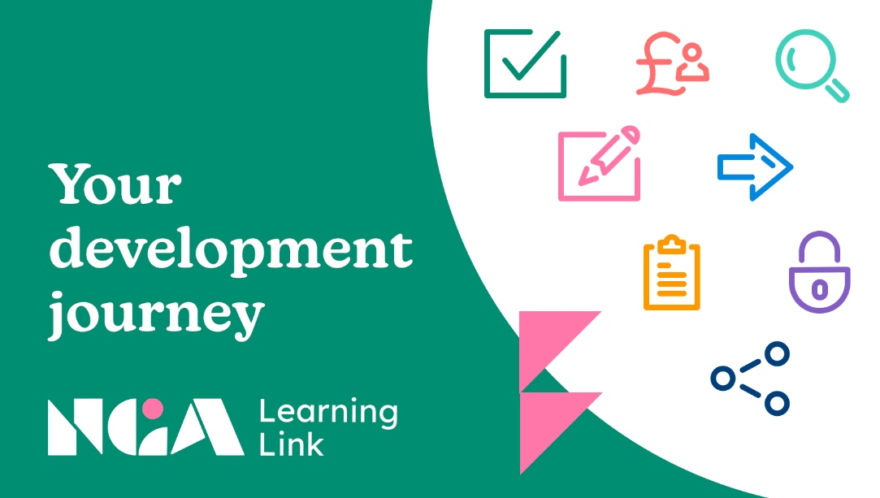 |  | Structures, roles and responsibilities  These modules will help you to understand school and trust structures, and what is expected of you as a governor or trustee.
Modules |  |  | Duration
Stakeholder engagement: the governance role |  |  | 15 mins
Effective MAT governance |  |  | 1 hr 15 mins
Introduction to local governance |  |  | 20 mins

Vision, ethos and strategic direction
Covering risk management, evaluating effectiveness and your role in school improvement, these modules will help you shape your school or trust’s strategic direction.
Modules | Duration
Equality, diversity and inclusion programme | 1 hr 30 mins
Creating a new vision for your school or trust | 15 mins

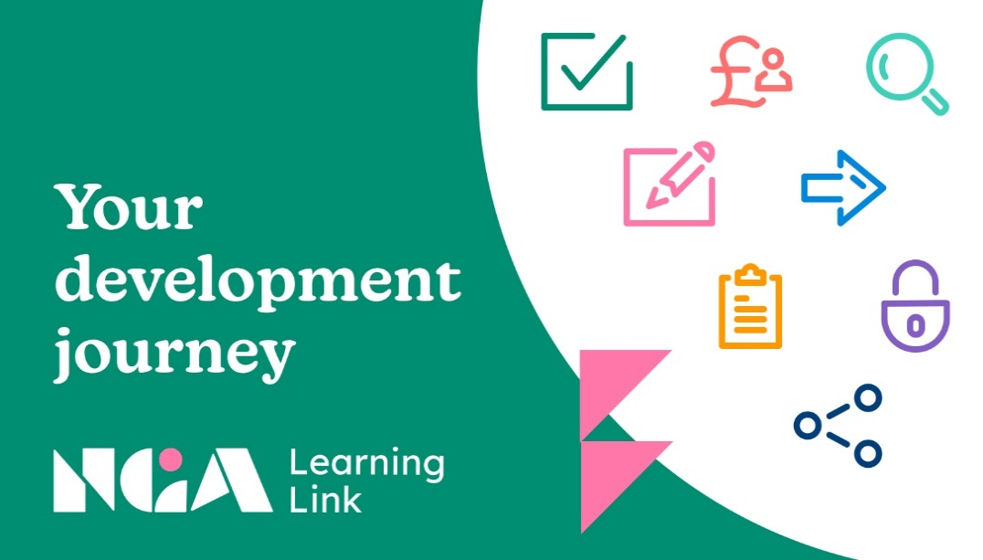
Good governance
These modules aim to help you improve the effectiveness of your governing board, including visiting your school or schools, Ofsted inspections and succession planning.
Modules | Duration
Handling difficult situations | 55 mins
Ofsted inspections: a guide for governing boards | 45 mins
Succession planning | 40 mins
Governance monitoring: a tool to help drive improvement | 10 mins
Holding to account: how to question and challenge | 15 mins
Holding to account: how to conduct a courageous conversation | 15 mins
Ethical Leadership: a planning tool | Up to 45 mins
Interactive NGA skills audit | Up to 60 mins
Environmental sustainability: the governance role | 30 mins

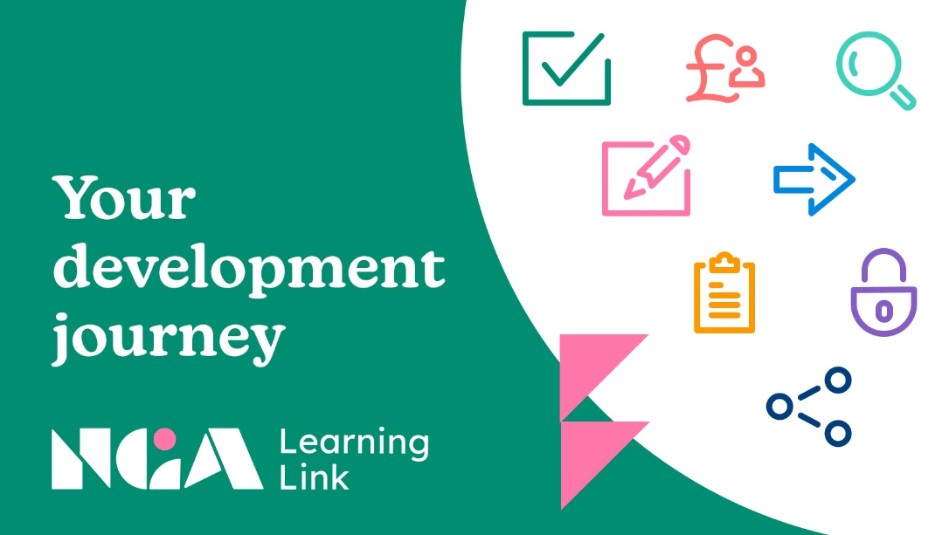
Pupil success and wellbeing
These modules focus on the core purpose of your schools or trust – the quality of education it should be providing to pupils.
Modules | Duration
Arts, culture and creativity: improving your school or trust and its curriculum | 45 mins
Monitoring performance data and targets | 50 mins
The governance of SEND | 30 mins
Pupil premium | 55 mins
Minimising exclusions | 15 mins
Panel work programme | 3 hrs

Staffing
These modules cover the key stages in the lead executive recruitment process and the critical role the board has in holding executive leaders to account through effective headteacher appraisal.
Modules | Duration
Headteacher appraisal and capability | 55 mins
Setting performance objectives for executive leaders | 15 mins
Recruiting a senior executive leader | 1 hr
Management of workload and wellbeing: the governance role | 15 mins

Finance
These modules will provide you with the tools and approaches for developing financial efficiency in your school or trust.
Modules | Duration
Effective financial governance in schools and trusts | 1 hr
Using Integrated Curriculum and Financial Planning (ICFP) | 15 mins
Compliance
Covering key areas of compliance such as safeguarding, health and safety and admissions, these modules will make you aware of the most important points from legislation and guidance.
Modules | Duration
Essential safeguarding for governors and trustees | 1 hr
Health and safety | 1 hr
Safer recruitment | 1 hr 15 mins
Handling complaints in schools and trusts | 45 mins
A whole-school approach to food | 1 hr 30 mins
NEW! Cyber security and governance | 30 mins

Clerking
These modules will help new and experienced clerks to get a better understanding of their role and how to carry it out well.
Modules | Duration
Panel work: an introduction | 25 mins
How to: review suspensions and exclusions | 45 mins
How to: run an effective admissions appeal panel | 45 mins
How to: run an effective HR review panel | 45 mins
How to: run an effective complaints review panel | 45 mins
Introduction to clerking programme | 10 mins
What does the governance professional do? | 40 mins
How governance works | 40 mins
How to: clerk in different types of school organisation | 20 mins
How to: find and use key sources for governance | 30 mins
How to: arrange meetings | 20 mins
How to minute a meeting effectively | 40 mins
How to: manage information and documents | 20 mins
How to: support the membership of the board | 30 mins
Clerking in new contexts: MAT local governance tier | 2 hours
Clerking in new contexts: LA maintained governing board | 2 hours
Clerking in new contexts: academy trust boards | 2 hours
How to: support the development of the board | 30 mins
How to: become a trusted advisor | 30 mins
How to: clerk courageously | 30 mins

Further online modules

Included in the NGA learning Link offer are a range of modules developed by Virtual College for a wider audience, which provide useful background information on a range of topics with relevance to governance such as important aspects of safeguarding and health and safety.

